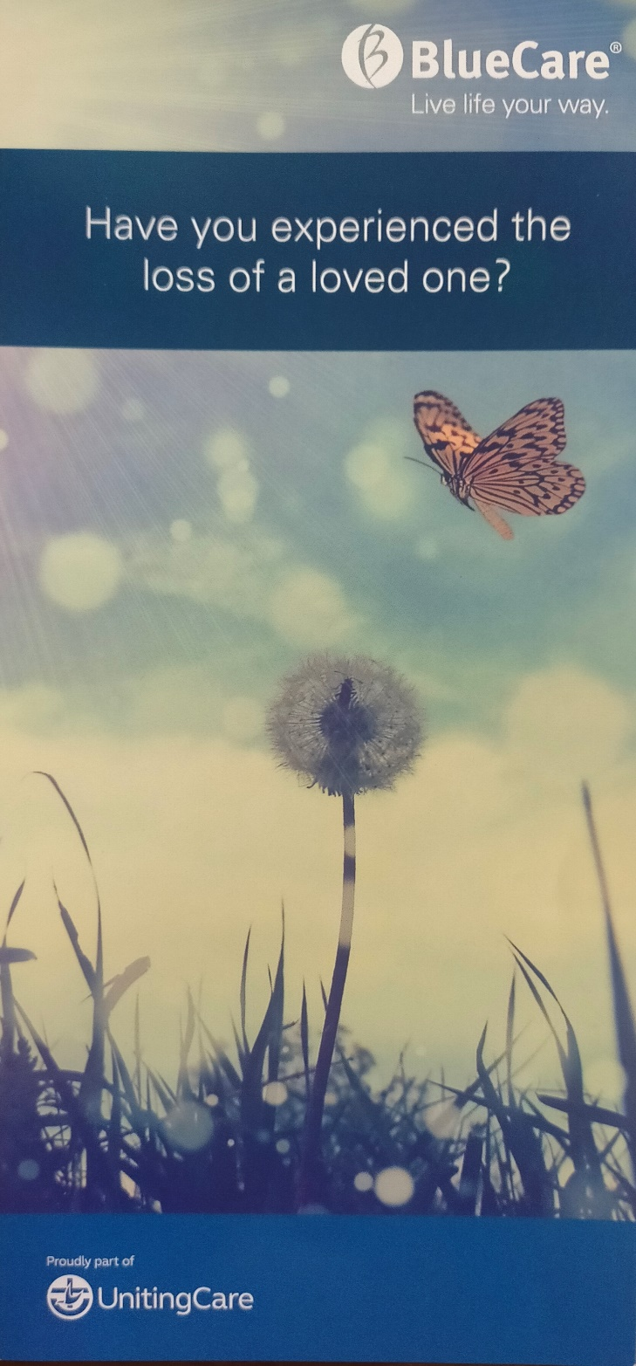
BlueCare Grief and Loss Program at Kenmore

People experience grief in many ways. It is normal for bereavement to bring with it a mixture of intense feelings of sadness, confusion, anger and fear as well as memories of happier times. BlueCare recognises that some people may need extra support during this journey and since 1990 has been conducting a specialised Grief and Loss program. The Program has several aims: to provide information on the grief process, to offer practical advice following the loss of a loved one, to provide emotional and social support, and to provide strategies to enhance effective coping skills.
David Savage and Kaye Ronalds, who have been running groups for many years, will facilitate the next BlueCare Grief and Loss Program in Kenmore starting in early February 2026. The Program runs for 2 hours a week for 7 weeks and will be held in the Community Centre at Kenmore Uniting Church. Registrations forms will be available soon from the church office. You can also enquire / give an expression of interest via BlueCare’s website by typing in “BlueCare Grief and Loss Program” into your favourite search engine and follow the links. Alternatively, contact the Kenmore Uniting Church office or phone 0417 555 826 (this is the main contact number for the Program administration).

